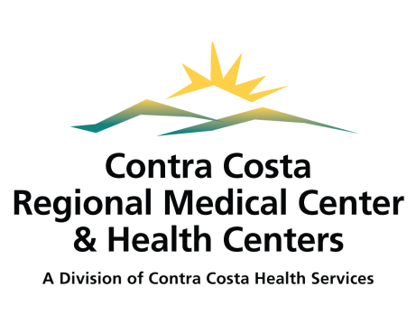

Proxy Access Request to myccLink

PATIENT INFORMATION
Patient Name: Date of Birth: Mailing Address: Phone Number: SSN: Patient Email: Shared Email: ◻ Yes ◻ No
PROXY REPRESENTATIVE INFORMATION
Proxy Name: Date of Birth: Mailing Address: _ Phone Number: SSN: Proxy Email: Shared Email: ◻ Yes ◻ No
SIGNATURE(S) AND ACKNOWLEDGEMENT
Disclosure: This request only allows Proxy Representative to have access to my health information via “myccLink”, including information regarding HIV/AIDS, Drug/Alcohol use, and Mental Health, if present.
- Proxy Access will automatically expire upon the provided legal document’s expiration date, or once a minor reaches 12 years of age, whichever comes first.
- I may refuse to sign this request. My refusal will not affect my ability to obtain treatment, payment, or eligibility for benefits.
- I may inspect or obtain a copy of the health information that I am being asked to allow the use or disclosure of
- I may revoke this request at any time, but I must do so in writing and submit it to the following address:
Contra Costa Regional Medical Center
Health Information Management Department
Attn: myccLink Proxy Access
2500 Alhambra Avenue
Martinez, CA 94553
Fax: (925) 370-5275

- My revocation will take effect upon receipt, except to the extent that others have acted in reliance upon this request.
- I have the right to receive a copy of this request.
- By signing this request, I understand that Contra Costa Regional Medical Center & Health Centers (CCRMC&HCs) will give my Proxy Representative the same access and privileges that I have for “myccLink” to view portions of my protected health information. I also understand that additional information may be available to my proxy representative through the patient portal as CCRMC&HCs continues to implement this product.
- Information disclosed pursuant to this request could be re-disclosed by the Proxy Representative. Such re-disclosure is in some cases not prohibited by California Confidentiality of Medical Information Act (CMIA) and may no longer be protected by Health Insurance Portability and Accountability Act of 1996 (HIPAA). However, CMIA prohibits the person receiving my health information from making further disclosure of it unless authorization for such disclosure is obtained from me or unless such disclosure is specifically required or permitted by law.

Patient Signature: _ Date: _

Proxy Representative Signature: _ Date: _

- This form must be delivered to Health Information Management Department by the patient or proxy representative who will need to present a photo ID.

HIMD USE ONLY:
Relationship to Patient (indicate type of verification provided):
- Certified “Letters of Guardianship” ◻ Advance Healthcare Directive
- Certified “Letters of Conservatorship” ◻ Spouse/Domestic Partner
- Confirmed Parent/Minor Matching Address or Birth Cert ◻ Other (specify): _____________

MRN:
Parent/Guardian ID Verified by: Date:
Proxy ID Type: ID Number:
Request Expiration Date:

