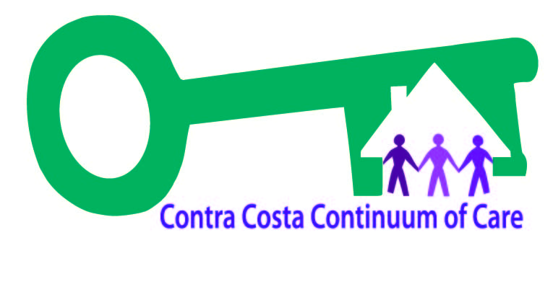
2024 Council on Homelessness Committees

This document briefly outlines Council on Homelessness (COH) committees and workgroups.

COMMITTEES and work groups: RECRUITING NOw

Equity Committee

PURPOSE: Increase awareness, community dialogue, and lead concrete actions to achieve equity throughout the homeless system of care.
WORKING GROUPS: Equity Work Group
2024 CoH MEMBERS (5): Hope Dixon, Iman Novin, Janae Thomas, Juno Hedrick, Leslie Gleason
Committee meetings: https://homebaseccc.zoom.us/meeting/register/tZEqc-CppzMvEtVzRM4K086_qnixRtjy8-KI
Working Group meetings: https://homebaseccc.zoom.us/meeting/register/tZUqc--sqj8jGdRiLuG6y5vuafMckcRseJjn

Funding Committee

PURPOSE: Direct the community input process for several time-sensitive federal and state funding streams, including revising scoring tools for the Continuum of Care Notice of Funding Opportunity (CoC NOFO) competition.

Committee meetings: TBD
Working Group meetings: https://homebaseccc.zoom.us/meeting/register/tZcudO-uqj0rHt3bOlVXM20HQd00NYK35E82#/registration
2024 CoH MEMBERS (5): Dani Jimenez, Deanne Pearn, Juno Hedrick, Nicole Greene, Wayne Earl

Governance Committee [Ad hoc]
PURPOSE: Review and revise the Governance Charter and Bylaws to increase CoH efficiency and impact.
WORKGROUPS: Governance Work Group
COMMITTEE MEETINGS: TBD
2023 CoH MEMBERS (4): Dani Jimenez, Juno Hedrick, Nicole Green, Tony Ucciferri

Oversight Committee

PURPOSE: Review and assess the development, implementation, and improvement of: CoC, Coordinated Entry System, HMIS database, and System Outcomes
WORKGROUPS: Oversight Work Group
Committee meetings: https://homebaseccc.zoom.us/meeting/register/tZ0vdu2orj8sHt2POmXWVJKhJebdcn-qwtu8
Working Group meetings: https://homebaseccc.zoom.us/meeting/register/tZAkc-2qqjgsH9Z3JnimRahkeDb803kYLgPB
2024 CoH MEMBERS (7): Alejandra Chamberlain, Carolyn Foudy, Deanne Pearn, Juno Hedrick, Leslie Gleason, Mia Fairbanks, Wayne Earl

PATH (Plan For accelerating transformative housing) Innovations Committee

PURPOSE: Work towards the goal of reducing unsheltered homelessness in Contra Costa County by 75% by 2024
WORKGROUPS: PATH Innovations Work Group
Committee meetings: https://us02web.zoom.us/meeting/register/tZEld-uhrjMoH9fFuTqxYYkIBZCIQstsMo9F#/registration
Working Group meetings: https://us02web.zoom.us/meeting/register/tZEld-uhrjMoH9fFuTqxYYkIBZCIQstsMo9F#/registration
2024 CoH MEMBERS (7): Deanne Pearn, Iman Novin, Juno Hedrick, Shawn Ray, Teri House, Tony Ucciferri, Wayne Earl

HMIS (Homeless Management Information System) Policy Committee

PURPOSE: Develops and shares updates on Homeless Management Information System (HMIS) policies & practices, compliance, & troubleshooting. Plans technical assistance & training.
WORKGROUPS: HMIS Policy Work Group
Committee meetings: https://homebaseccc.zoom.us/meeting/register/tZcufu6tqj8qEtXJZVG2JOxb6nSNgtiZt8RB
Working Group meetings: https://homebaseccc.zoom.us/meeting/register/tZwuc-mqrTsuGd2_LecJOWbZ2tMjkrKpfMQ7
2024 CoH MEMBERS (6): Alejandra Chamberlain, Jo Bruno, Jai De Lotto, Juno Hedrick, Nicole Green, Tony Ucciferri

COMMITTEES and workgroups: RECRUITING LATER

NOMINATING Committee [ad hoc]
PURPOSE: Reviews applications for potential new ESTIMATED TIMING: August to October 2024
CoH members and provides recommendations to
the full Council

HOMELESSNESS Awareness Month WORKGROUP [ad hoc]

PURPOSE: Plan for annual Homelessness Awareness ESTIMATED TIMING: August to November 2024
Month (November) activities

Point-in-Time count WORKGROUP [ad hoc]
PURPOSE: Plan and implement the annual ESTIMATED TIMING: November 2024 to January 2025
Point-in-Time Count, an annual HUD-required
count of sheltered and unsheltered people
experiencing homelessness

